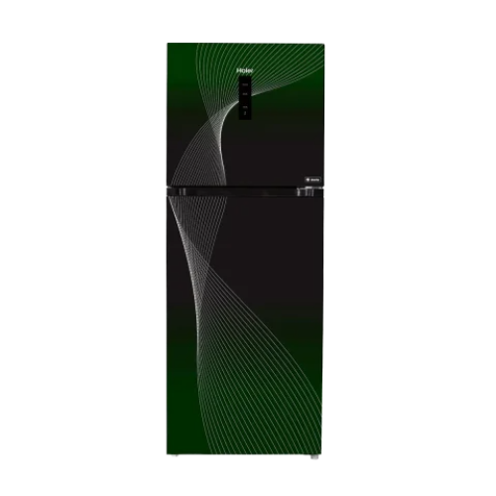**Liberty Electronics**

# Haier Digital Inverter Refrigerator 18 CF (438 Liter) HRF-438ID/BA/RA

**₨115,000**

**   FD Inverter Technology**

**http://lahorelectronics.com/wp-content/uploads/2021/05/turbo-cooling-icon.png   Turbo Cooling (Turbo Fan)**

**   Digital Control System**

Top of Form

Bottom of Form